DATAMINDS
Tawanda and Kistie
DATAMINDS
Data Pipeline for E-Commerce Order Fulfilment and Supply Chain Management

Contents
CHAPTER ONE: INTRODUCTION 3
1.1 Introduction 3
1.2 Problem Statement 4
1.3 Background and Motivation 4
1.4 Aim and Objectives 6
1.5 Significance of the Project 6
1.6 Project Scope 6
1.7 Project Timeline 7
1.8 Conclusion 7
CHAPTER 2: LITERATURE REVIEW 8
2.1 Introduction 8
2.2 Review Methodology 8
2.3 Data Engineering and Data Pipelines 9
2.4 E-commerce Logistics and Supply Chain Data 9
2.5 Data Quality and Integration Challenges 10
2.6 Cloud-Based Data Pipelines 10
2.7 Research Gaps 10
2.8 Conclusion 11
Chapter 3 12
3.1 Introduction 12
3.2 Software Development Methodology 12
3.3 Tools and Technologies 12
3.4 Conclusion 13
Chapter 4: System Design and Implementation 14
4.1 Introduction 14
4.2 System Architecture Design 14
4.3 Logical Design 16
4.4 Process Flow Between Components 17
4.5 Physical Design 17
4.6 Functional Requirements 18
4.7 Non-Functional Requirements 19
CHAPTER 5: SYSTEM TESTING AND VALIDATION 19
5.1 Introduction 19
5.2 Data Ingestion Functionality 20
5.3 Data Transformation Functionality 21
5.4 Testing Session 23
5.4.1 Types of Testing Conducted 23
5.5 Conclusion 24
REFERENCES 25

ABSTRACT
The rise of e-commerce has contributed to the increasing complexity of order fulfilment and supply chain activities in a world where logistics data tends to be siloed into different systems. This data engineering and cloud-based analytics project is a response to the challenge of integrating and transforming operational data to be reliable, analytic ready datasets for better decision making.
The research focuses on development of cloud based data pipeline for e-commerce order fulfilment. We followed the Medallion Architecture (Bronze–Silver–Gold) approach to organize data ingestion, processing and storage. Simulation raw data on order, shipment and warehouse systems were processed by ingestion to Amazon S3, transformation in AWS Glue, using python and pandas and loading into Amazon Redshift with a dimensional star schema model. Workflow orchestration was automated with Apache Airflow and Grafana was used to visualize interactive dashboards for performance monitoring. Implemented system allowed for consolidation of fragmented logistics data, enhanced data quality through automated check and visualization of KPIs like delivery tim or fulfilment ratio. The project shows a functional end-to-end cloud data pipeline reference model for national e-commerce logistical and practical insights on scalable data engineering solutions in developing regions.

CHAPTER 1: INTRODUCTION

Introduction
The rapid growth of e-commerce has transformed how goods and services are bought, sold, and delivered across the world (Laudon and Traver, 2023). In Southern Africa, logistics companies play a critical role in enabling cross border and local e-commerce by managing order fulfilment, warehousing and last mile delivery(World Bank, 2022a).As transaction volumes increase, so does the complexity of handling large amounts of operational data generated from orders, inventory, transportation and customer interactions (Chopra and Meindl, 2021). This growth in data requires organizations to adopt more advanced data management and processing approaches to remain competitive (Waller & Fawcett, 2019).In modern organizations, data-driven decision making is essential for improving efficiency, reducing costs, and enhancing customer satisfaction (Provost and Fawcett, 2013). This has increased the demand for robust data engineering solutions, particularly data pipelines that can ingest, process, and deliver reliable data for analytics and operational use (Kleppmann, 2017).This project focuses on designing and implementing a data engineering pipeline for e-commerce order fulfilment and supply chain operations. The aim is to support timely insights, operational visibility, and informed decision making in logistics environments(Kimball and Ross, 2013).

Problem Statement
Despite the availability of large volumes of operational data in e-commerce logistics, many organizations struggle to integrate, process and effectively utilize this data(Batini et al., 2016). In companies, information related to orders, shipments, delivery times, warehouse operations, and customer feedback is often generated from multiple systems and stored in different formats (Hazen et al., 2014).As a result, reporting is frequently delayed and real-time visibility into order fulfilment processes is limited (Kache and Seuring, 2017). Data inconsistencies and poor data quality further undermine operational decision making and reduce confidence in analytical outputs. (Batini and Scannapieco, 2016)The lack of integrated data makes it difficult to track overall supply chain performance and identify operational bottlenecks (Chopra and Meindl, 2021). In addition, reliance on manual data handling increases operational risks, processing delays, and the likelihood of human error (Redman, 2018).Without a well-designed data pipeline, transforming raw logistics data into accurate, timely, and actionable insights becomes challenging (Kleppmann, 2017). This ultimately hinders efficient supply chain management, scalability, and customer service performance in e-commerce logistics operations (Waller and Fawcett, 2019).

Background and Motivation
The rapid expansion of e-commerce in Southern Africa has significantly increased the demand for logistics systems that are reliable, transparent, and capable of supporting fast order fulfilment across both urban and remote regions (Laudon and Traver, 2023). As online retail activity grows, logistics operations are under increasing pressure to handle higher transaction volumes while maintaining service quality and cost efficiency (World Bank, 2022a).
Operational efficiency in logistics organizations plays a critical role in determining customer satisfaction, delivery reliability, and overall profitability (Chopra and Meindl, 2021) . Inefficiencies in data handling, order tracking, and warehouse coordination can lead to delayed deliveries, increased costs, and reduced trust in e-commerce platforms (Kache and Seuring, 2017).
As students of data science specializing in data engineering, there is strong motivation to apply theoretical concepts such as data integration, ETL processes, and pipeline orchestration to real-world operational challenges (Provost and Fawcett, 2013). Practical, industry-focused projects provide an opportunity to bridge the gap between academic knowledge and professional skills required in modern data-driven organizations (Waller and Fawcett, 2019).
The logistics and supply chain sector is particularly data-intensive, generating large volumes of structured and semi-structured data from order management systems, transportation platforms, warehouse management systems, and customer feedback channels (Hazen et al., 2014). However, this data is often fragmented across multiple systems, limiting its usefulness for analytics and operational decision making without effective data engineering solutions (Batini and Scannapieco, 2016).
This project is motivated by the need to address core data integration, transformation, and pipeline orchestration challenges commonly encountered in logistics environments (Kleppmann, 2017). By designing and implementing a robust data pipeline, the project demonstrates how raw operational data can be transformed into consistent, high-quality datasets suitable for real-time monitoring, performance analysis, and strategic planning (Kimball and Ross, 2013).
Beyond its technical contribution, the project provides valuable insights into how data engineering supports supply chain visibility, risk reduction, and process optimization (Redman, 2018). Improved data availability and quality enable organizations to identify bottlenecks, forecast demand, and respond proactively to operational disruptions (Chopra and Meindl, 2021).
From an academic and professional perspective, this project serves as a capstone demonstration of applied data engineering competencies, including data modelling, pipeline automation, and quality management (Batini and Scannapieco, 2016). The practical nature of the project enhances portfolio readiness and prepares students for roles in data engineering, analytics, and digital transformation initiatives within the logistics and e-commerce sectors (Waller and Fawcett, 2019).

Aim and Objectives
Aim: To build a cloud-based data pipeline that consolidates e-commerce fulfillment data for end-to-end supply chain visibility and analytical reporting.

Objectives

- Ingest and integrate data from multiple e-commerce and logistics sources into a unified pipeline.
- Store processed data in a centralized repository optimized for analytics and reporting.
- Provide analytics-ready datasets to monitor order fulfilment and supply chain performance.
- Visualize operational performance using interactive dashboards highlighting trends and bottlenecks.

Significance of the Project
The pipeline will provide data-driven insights to reduce operational costs, improve delivery reliability, enhance customer communication with real time tracking and support strategic decisions regarding warehouse and fleet management.

Project Scope
- Focus on the domestic e-commerce parcel delivery process within South Africa.
- Development using simulated or anonymized datasets representing operational data (orders, shipments, tracking events, warehouse logs).
- Building a functional prototype pipeline on a major cloud platform (AWS, GCP, or Azure).
- Creating analytics dashboards for historical and current performance
- The focus remains on data engineering and pipeline automation rather than advanced predictive modeling.

1.7 Project Timeline
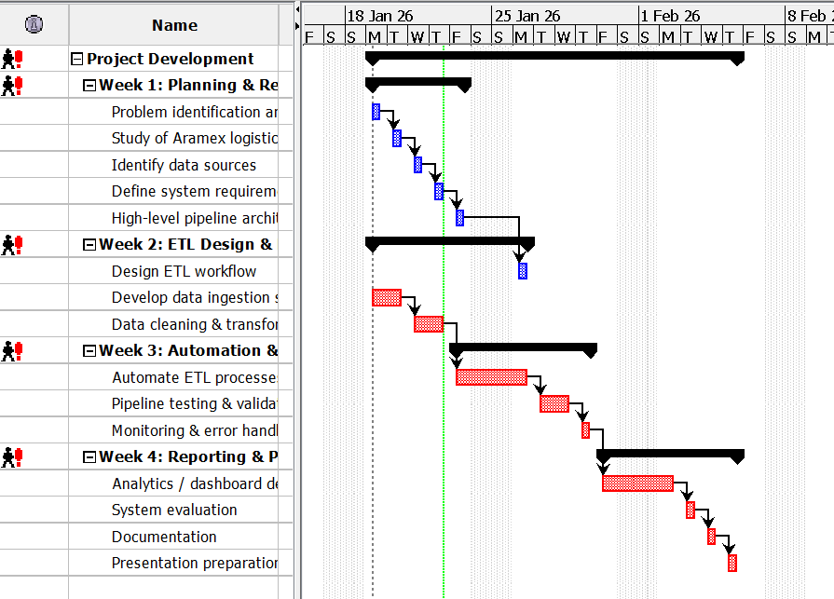

1.8 Conclusion
This chapter introduced the study by outlining the background, problem statement, objectives, and significance of the project. By focusing on an e-commerce order fulfilment and supply chain data pipeline, the project aims to bridge theoretical knowledge and practical data engineering skills, preparing the student for industrial attachment and real-world challenges.

CHAPTER 2: LITERATURE REVIEW

2.1 Introduction
This chapter presents a systematic literature review of existing academic and industry literature related to data engineering pipelines, e-commerce logistics and supply chain data management. The purpose of the literature review is to establish a theoretical and practical foundation for the project by examining how previous studies have addressed data integration, ETL processes and analytics in logistics and e-commerce environments. The chapter also identifies limitations in current research and practice particularly within developing regions such as Southern Africa thereby justifying the need for the proposed study.
This systematic review is guided by the following research questions:
- What data engineering architectures and ETL models are proposed in existing literature?
- What data integration and quality challenges are common in e-commerce logistics systems?
- What limitations exist in implementing cloud-based data pipelines in developing regions such as Southern Africa?
- Where do gaps exist between theoretical pipeline models and practical operational implementation?

2.2 Review Methodology
The literature review was conducted using peer reviewed academic journals, textbooks, conference proceedings and industry reports related to data engineering, supply chain management and e-commerce logistics. Emphasis was placed on recent literature (2013–2024) to ensure relevance to modern cloud based and data driven environments. Industry reports from organizations such as the World Bank were also reviewed to provide regional context for logistics operations in Southern Africa.
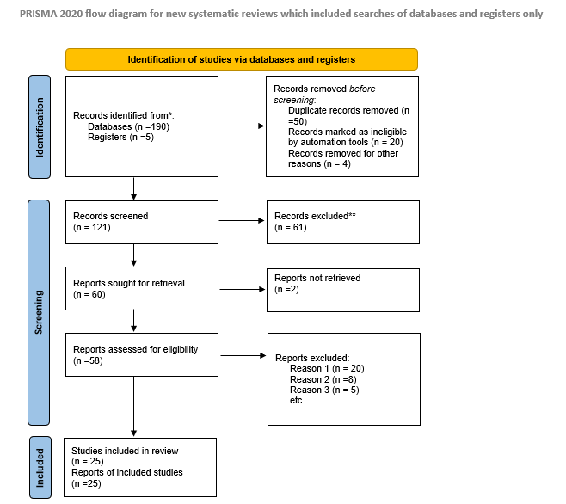

2.3 Data Engineering and Data Pipelines
Previous literature defines data engineering as the discipline responsible for building reliable systems that move data from operational sources to analytical platforms. Traditional batch based ETL pipelines have been widely used for reporting but research shows that they struggle with the scale and speed of modern e-commerce data (Kimball and Ross, 2013).
More recent studies advocate for automated and scalable pipeline architectures that reduce latency and improve data consistency (Provost and Fawcett, 2013). However, many of these studies remain conceptual or cloud-architecture focused.
This study builds on existing work by implementing a practical end-to-end data pipeline that automates ingestion, transformation and storage of logistics data demonstrating how theoretical pipeline concepts can be applied in a real operational context.

2.4 E-commerce Logistics and Supply Chain Data
The literature shows that e-commerce logistics generates large volumes of data across order fulfilment, warehousing, transportation and last-mile delivery (Chopra and Meindl, 2021). This data is typically spread across multiple systems which creates fragmented data environments and limits end-to-end supply chain visibility (Kache and Seuring, 2017).
Although previous studies emphasize the value of data integration and analytics for improving logistics performance (Waller and Fawcett, 2019) most focus on large organizations in developed economies. My proposed study differs by addressing these challenges within a developing country context using realistic logistics data and focusing on integration rather than analytics alone.

2.5 Data Quality and Integration Challenges
Research consistently identifies data quality issues as major barriers to reliable decision making in logistics systems (Batini and Scannapieco, 2016). These problems are often worsened by manual data handling and spreadsheet-based reporting, which increase errors and delays (Redman, 2018).
While the literature recommends automated and standardized ETL processes to address these challenges (Kleppmann, 2017), many studies stop at recommendations. My study directly addresses this gap by implementing automated ETL workflows with built-in data validation to improve data reliability and consistency.

2.6 Cloud-Based Data Pipelines
Existing research shows that cloud platforms enable scalable, cost effective data pipelines and support fluctuating e-commerce workloads (Waller and Fawcett, 2019). Cloud based pipelines also allow faster development and easier system maintenance compared to traditional on premise solutions (Kimball and Ross, 2013).
However, the literature highlights a gap between generic cloud pipeline architectures and practical implementations tailored to specific logistics contexts, especially in developing economies (World Bank, 2022b). This project addresses that gap by designing a cloud-based pipeline specifically for domestic e-commerce parcel delivery, focusing on operational visibility rather than theoretical architecture. Despite these advantages the literature notes a gap between theoretical pipeline architectures.

2.7 Research Gaps
Despite extensive literature on data management and supply chain theory, specific gaps remain, particularly in the Southern African context. First, a contextual implementation gap persists, as much existing literature proposes generic architectures or focuses on global north infrastructures, with limited documented research on implementing cloud native data pipelines tailored to the operational realities, connectivity challenges, and data maturity levels of logistics firms in the region (World Bank, 2022a). Second, there is an integration-over-modeling gap while many studies acknowledge data fragmentation, their proposed solutions often emphasize technological integration over the practical design of consolidated, business friendly data models that are immediately usable for analytics in logistics. Third, a notable gap exists between theoretical frameworks for data driven supply chains and practical, end-to-end prototypes that demonstrate the pipeline's tangible value from raw data ingestion to operational dashboards especially when using accessible cloud technologies.

2.8 Conclusion
This chapter reviewed literature related to data engineering pipelines, e-commerce logistics, data quality and cloud based analytics. The review established that effective data pipelines are essential for transforming fragmented logistics data into actionable insights. While existing studies provide valuable theoretical foundations, gaps remain in practical, region-specific implementations, particularly within Southern Africa.
The proposed project addresses these gaps by designing and implementing a cloud based data pipeline for e-commerce order fulfilment and supply chain operations. By focusing on data integration, automation and analytics readiness, the project contributes both academically and practically to the understanding of how data engineering supports modern logistics environments.

Chapter 3: Methodology

3.1 Introduction
This chapter outlines the methodological approach and technical framework for designing and implementing the cloud-based data pipeline. The methodology is designed to achieve the project's aim of consolidating e-commerce fulfilment data for enhanced supply chain visibility. It details the structured process for development, justifies the chosen software development lifecycle, and specifies the tools and technologies that will be used to construct a functional, scalable and automated pipeline prototype.

3.2 Software Development Methodology
The project follows an Adaptive (Agile) development approach, incorporating Scrum and Kanban principles within a structured systems development lifecycle.
Development is carried out iteratively in incremental stages:
- Define pipeline components to be developed (e.g., ingestion layer, ETL scripts, storage schema).
- Implement individual components such as data ingestion jobs, transformation scripts and storage configuration.
- Validate data accuracy, transformation logic and integration between components.
- Deploy pipeline components to the AWS environment.
- Refine transformations and storage models based on testing results.

3.3 Tools and Technologies
- Amazon Web Services (AWS)
- AWS Glue / Apache Kafka (MSK)
- SQL (via AWS Glue/ETL Jobs), Python (PySpark)
- Apache Airflow
- Amazon S3 (Data Lake), Amazon Redshift
- Amazon QuickSight / Tableau Public
- Git / GitHub
- AWS CloudFormation / Terraform

3.4 Conclusion
This chapter has defined a pragmatic and industry-aligned methodology for the project. By adopting an adaptive Agile approach, the development process remains flexible and responsive. The selected technology stack, centered on AWS cloud services, provides the necessary managed components to efficiently build, automate and scale the data pipeline. This methodology and toolset are directly tailored to meet the stated objectives of data integration, ETL automation, centralized storage and analytical delivery forming a solid foundation for the system design and implementation detailed in the next chapter.

Chapter 4: System Design and Implementation

4.1 Introduction
This chapter presents the detailed design and implementation of the cloud-based data pipeline for e-commerce order fulfilment and supply chain management. The chapter is structured into four main sections: system architecture design (conceptual, logical and physical), the rationale for adopting Medallion Architecture, implementation of each pipeline layer and the functional specifications of the complete system.

The system was designed using the Medallion Architecture (Bronze–Silver–Gold) layered approach to ensure scalable data processing, improved data quality and analytics readiness. The architecture supports structured ingestion, transformation, storage and visualization of logistics data in a controlled and automated manner.

4.2 System Architecture Design

The overall system architecture follows a cloud-native design model deployed on AWS.

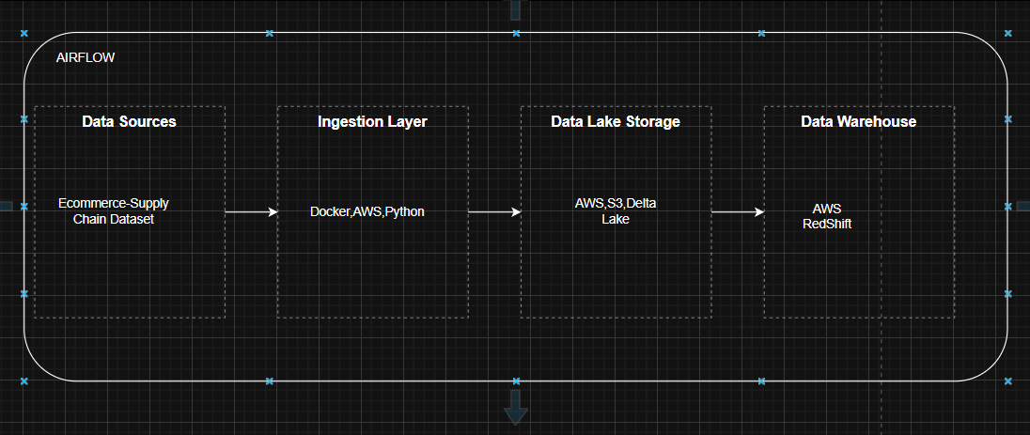
Architectural Components:
- Data Sources
  - E-commerce order system
- Ingestion Layer
  - Python
  - Batch ingestion process
- Storage Layer
  - Amazon S3 (Data Lake: Bronze & Silver)
  - Amazon Redshift (Gold layer warehouse)
- Orchestration Layer
  - Apache Airflow (workflow scheduling and automation)
- Analytics Layer
  - PowerBI
Client-Side and Server-Side Integration
The system follows a cloud-hosted server-side architecture.
Server-Side Components:
- Docker
- Amazon S3 (data lake)
- Amazon Redshift (data warehouse)
- Apache Airflow (orchestration)
These components handle:
- Data ingestion
- Data transformation
- Data storage
- Data processing
- Workflow automation
Client-Side Components:
- Business analysts
- Operations managers
- Supply chain managers
Users interact with the system through:
- PowerBI dashboards connected to Redshift
The client side does not directly interact with raw data but consumes processed insights from the Gold layer.

4.3 Logical Design
System Users
The system is designed for:
- Operations Managers
  - Monitor order fulfilment performance
  - Track delivery times
- Warehouse Supervisors
  - Track processing delays
- Logistics Analysts
  - Analyze shipment trends
  - Identify bottlenecks
- Executive Management
  - View high-level KPIs
System Processes
The system includes the following processes:
- Data Ingestion Process
  - Raw datasets uploaded to S3
  - Glue crawler detects schema
- Data Cleaning Process
  - Remove duplicates
  - Handle missing values
  - Standardize date formats
- Data Transformation Process
  - Create derived fields
  - Calculate delivery time differences
- Data Loading Process
  - Load cleaned data into Redshift
- Analytics Process
  - Dashboard queries executed
  - KPIs calculated dynamically

4.4 Process Flow Between Components

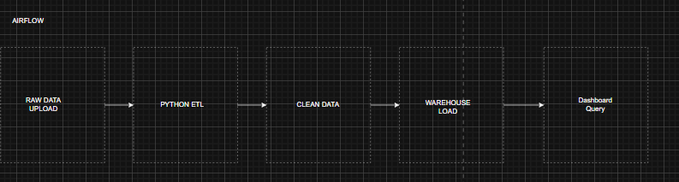
Airflow ensures:
- Scheduled execution
- Error handling
- Retry mechanisms
- Dependency management

4.5 Physical Design
The physical design represents the actual deployment environment on AWS.
Infrastructure Components:
S3 Buckets:
  - s3://bronze
  - s3://silver
Redshift Serverless:
  - Warehouse schema
  - Fact and dimension tables
Python:
  - Ingestion job
  - Transformation job
Airflow DAG:
  - Orchestrates pipeline execution
Data storage format:
- Parquet files (optimized for analytics)
Warehouse Model:
- Star schema
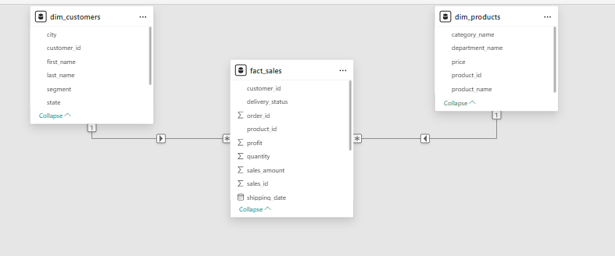
Tool
- Amazon S3
- AWS Glue
- Python
- Apache Airflow
- Amazon Redshift
- PowerBI

4.6 Functional Requirements
The system performs the following functions:
- Ingest logistics data from multiple sources.
- Store raw data securely in the cloud.
- Clean and validate data automatically.
- Transform data into analytics-ready format.
- Load processed data into a centralized warehouse.
- Provide dashboards displaying:
  - Order fulfilment rate
  - Average delivery time
  - Delayed shipment percentage
  - Warehouse processing time
- Automate daily pipeline execution.
- Maintain data consistency and reliability.

4.7 Non-Functional Requirements
- Scalability: Must handle increasing transaction volumes.
- Reliability: Scheduled automated execution.
- Security: Role-based access control (IAM).
- Performance: Optimized queries using Redshift.
- Availability: Cloud-hosted infrastructure.

CHAPTER 5: SYSTEM TESTING AND VALIDATION

5.1 Introduction
This chapter presents the implementation results, system testing procedures and validation of the cloud based data pipeline developed for e-commerce order fulfilment and supply chain management. The purpose of this chapter is to demonstrate that the system functions as intended meets the specified functional requirements and produces reliable analytics outputs.
The chapter includes screenshots of major system functionalities, selected code snippets, a description of testing methodologies and quality assurance measures applied throughout development.
Airflow Dag Code

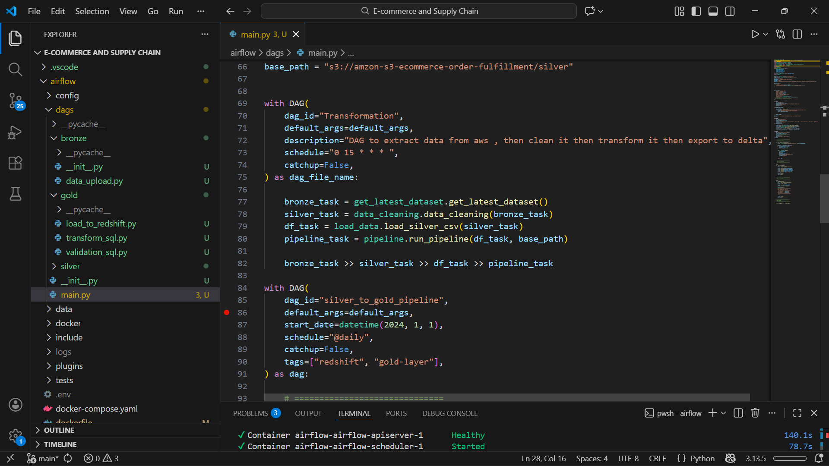

AWS upload to S3 Bucket
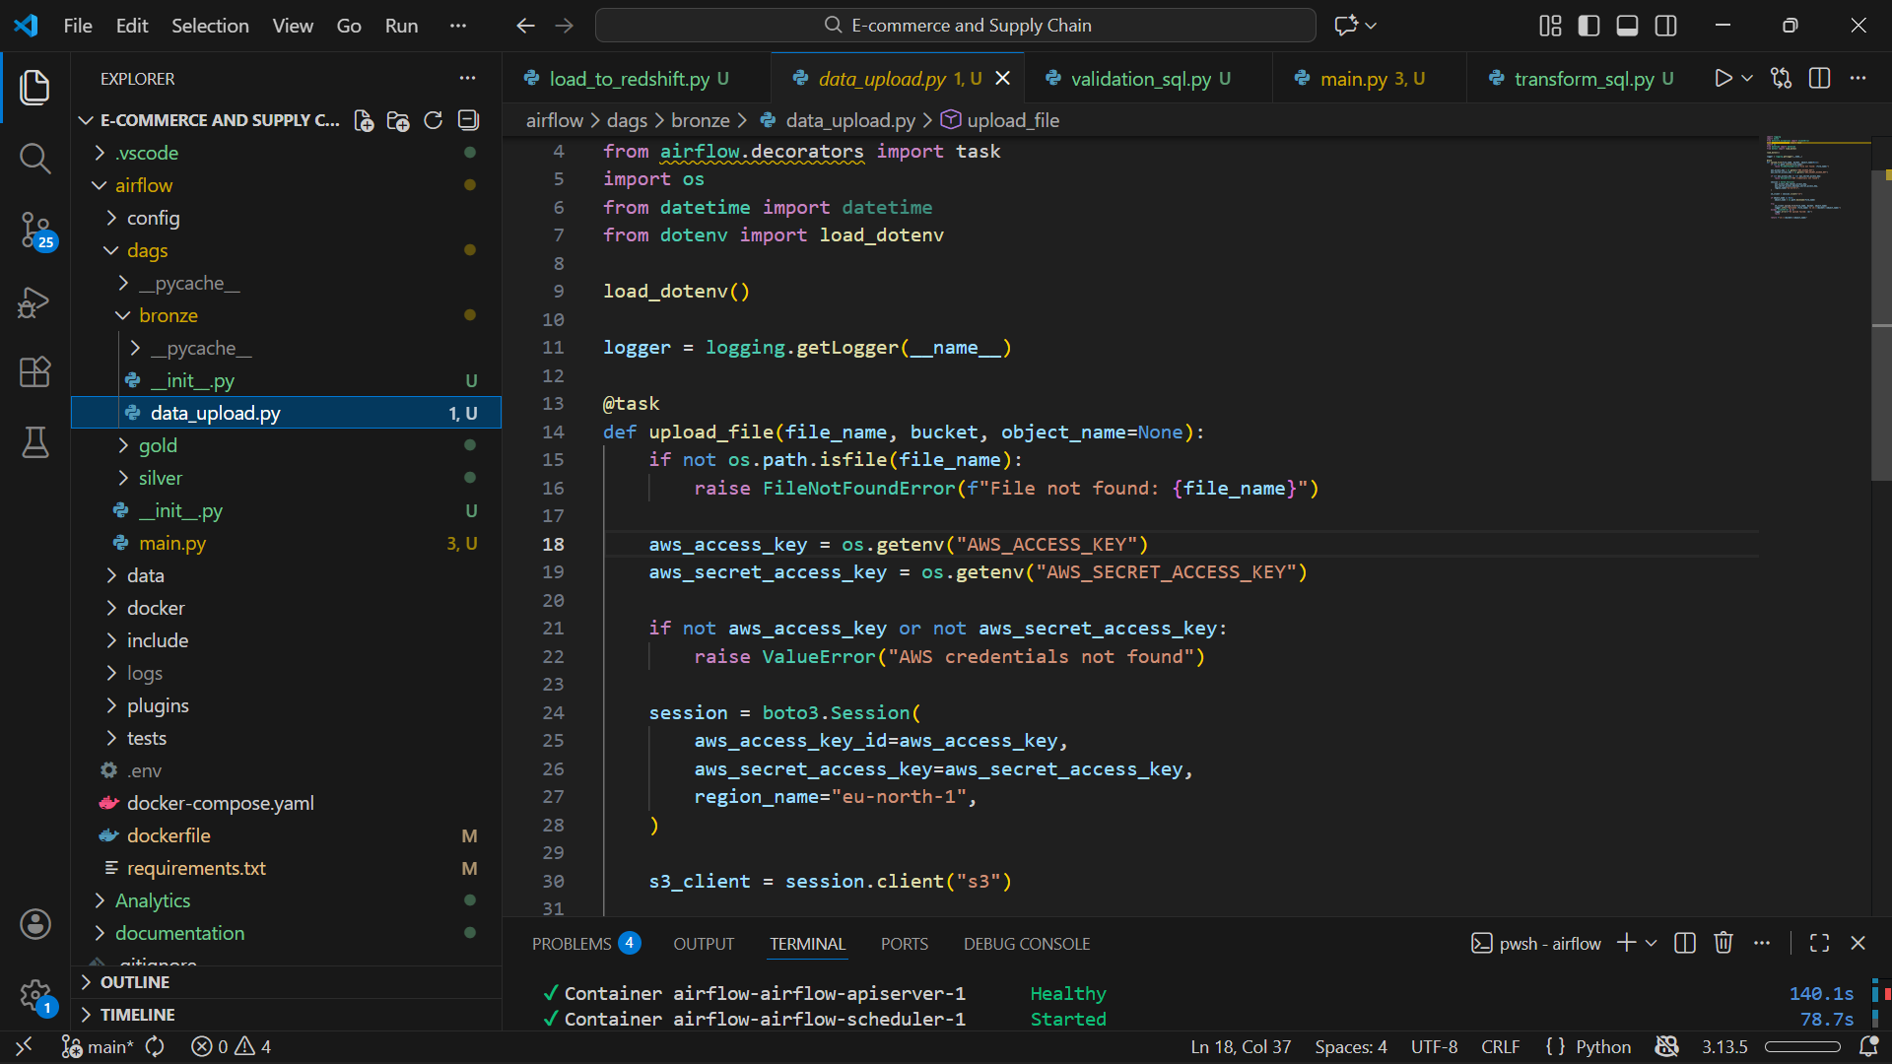

5.2 Data Ingestion Functionality
Description:
Raw logistics datasets (orders, shipments, warehouse logs) were successfully uploaded to the Amazon S3 Bronze layer and detected using AWS Glue crawlers.
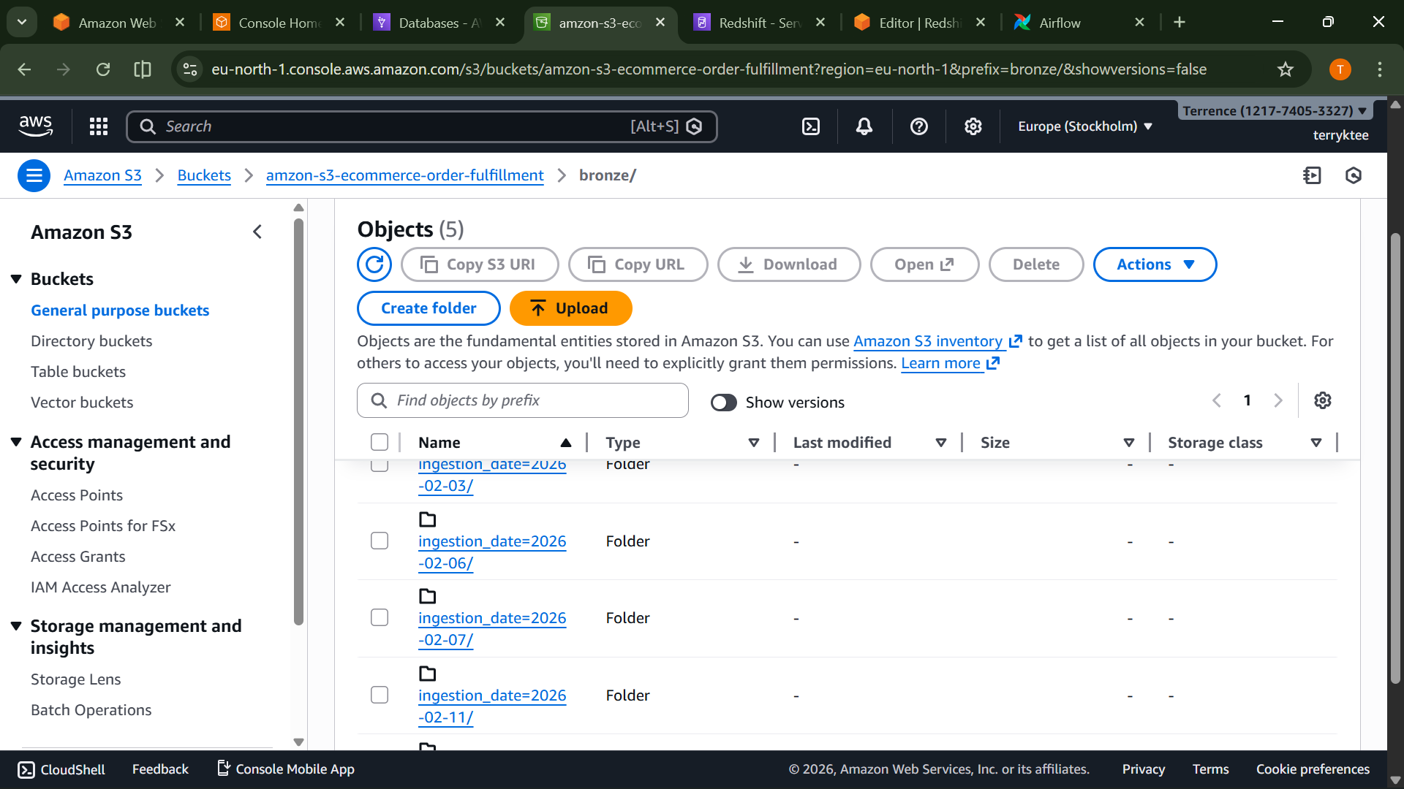

5.3 Data Transformation Functionality
Description:
Python library pandas was used to:
- Remove duplicate records
- Standardize date formats
- Handle null values
- Join order and shipment data
- Calculate delivery duration
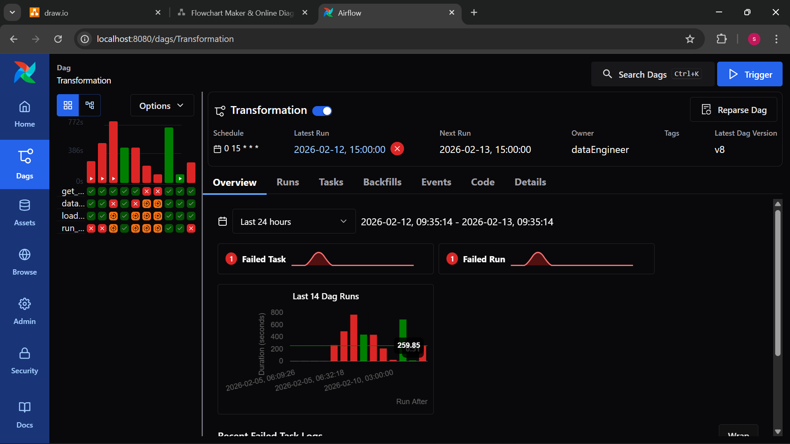
Data Warehouse Loading
Description:
Transformed data was loaded into Amazon Redshift using a star schema model.
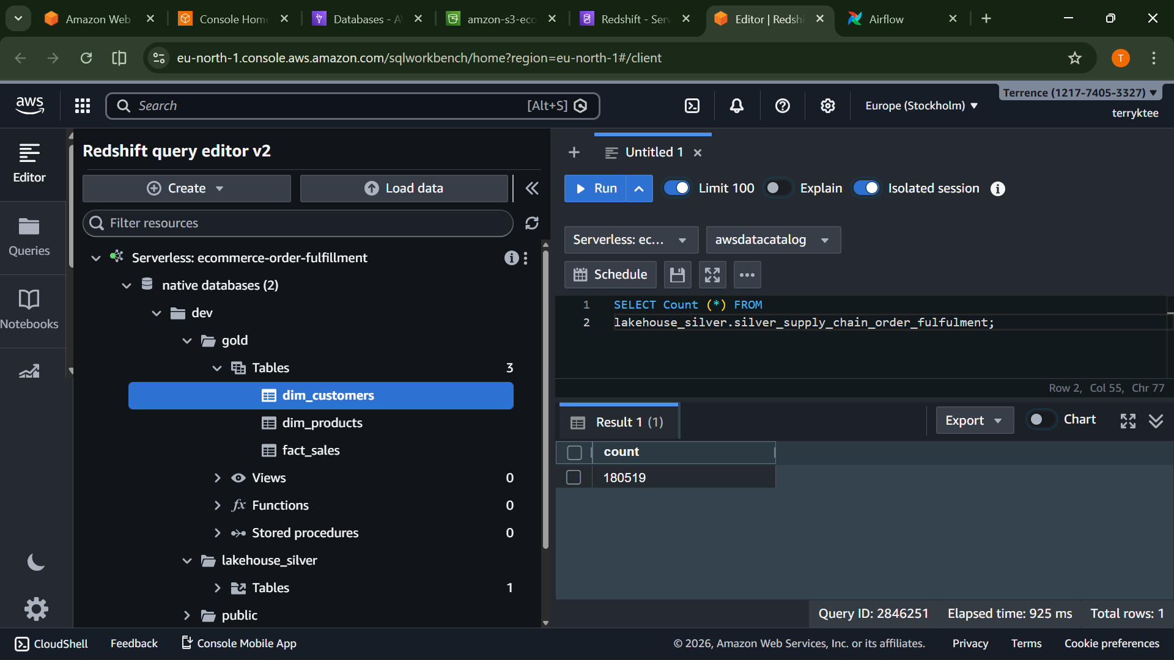

Dashboard and Analytics
Description:
Interactive dashboards were created using PowerBI.
KPIs visualized:
- Order fulfilment rate
- Average delivery time
- Percentage of delayed shipments
- Warehouse processing time
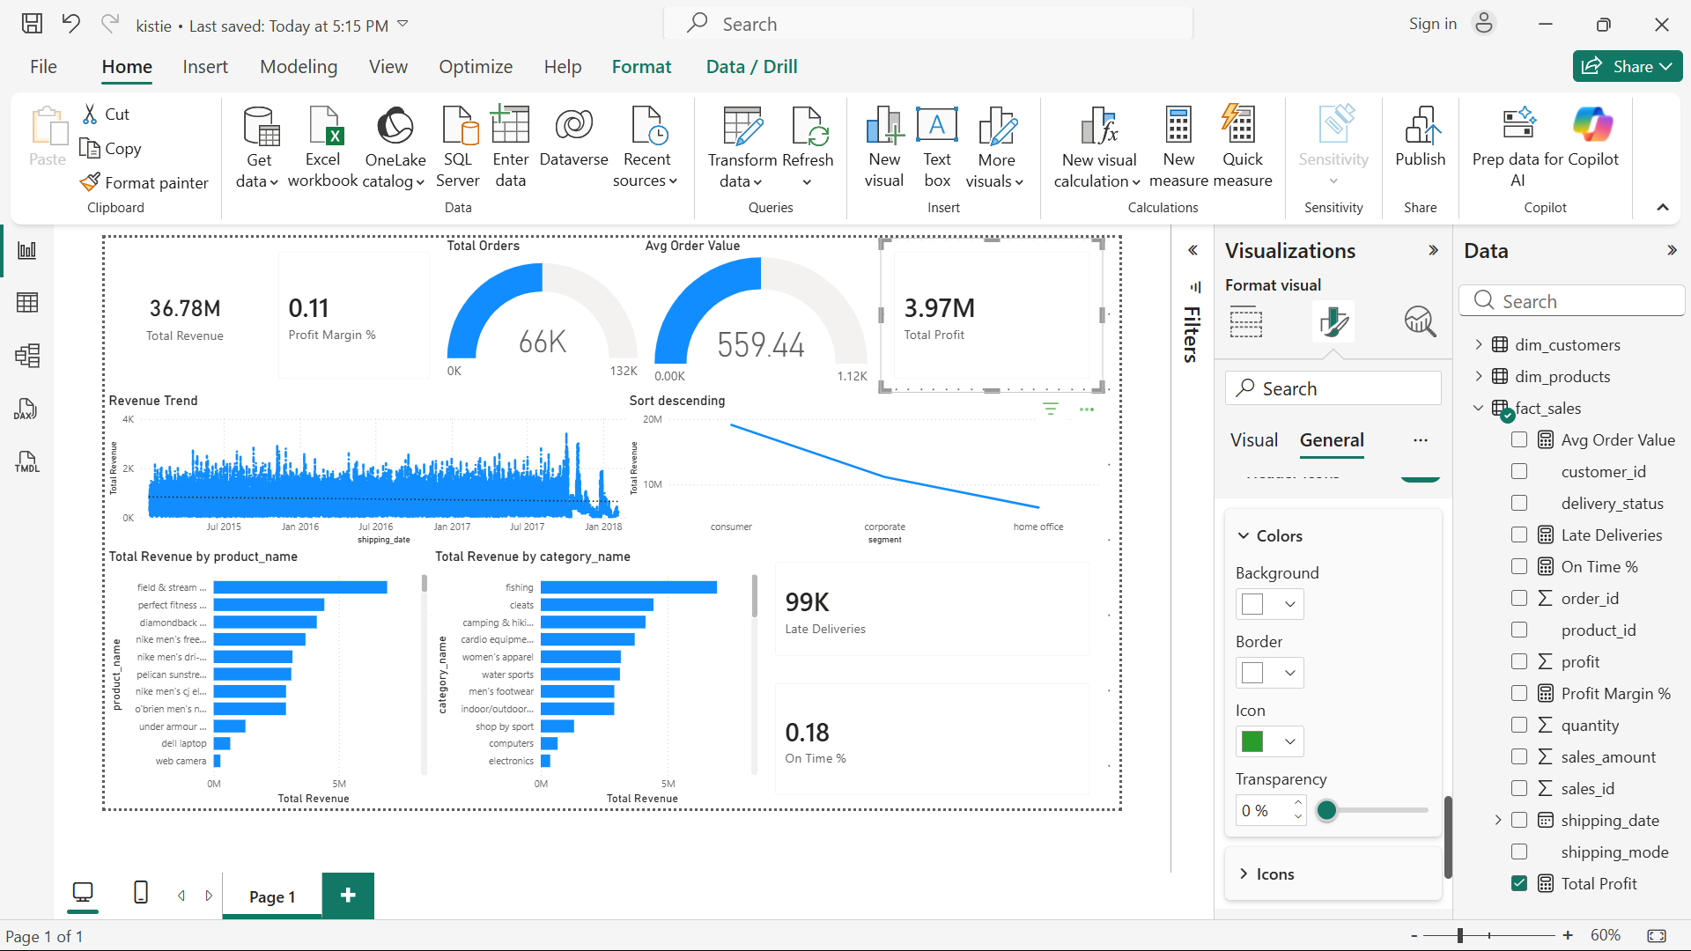

5.4 Testing Session
Testing was conducted to ensure the reliability, accuracy, and stability of the pipeline.

5.4.1 Types of Testing Conducted
Unit Testing
- Individual ETL scripts were tested separately.
- Schema validation performed.
- Null handling verified.
Integration Testing
- Verified data flow between:
S3 → Python(Pandas) → Redshift
- Ensured proper data transformation and loading.
System Testing
- End-to-end pipeline execution tested.
- Airflow DAG execution monitored.
- Dashboard queries validated.
User Acceptance Testing (UAT)
- Sample users reviewed dashboard insights.
- Verified KPI accuracy.
Test Participants
The system was evaluated by:
- Project developer (internal testing)
- Two classmates (peer validation)
- One supervisor (conceptual review)
Participants tested:
- Data accuracy
- Dashboard usability
- Query response time
- Error handling
Bugs identified included:
- Incorrect date format conversion
- Duplicate record issue in shipment table
- Delay calculation misalignment
All issues were corrected before final validation.

Quality Assurance Measures
Several mechanisms were implemented to ensure data and system quality.
Data Validation Rules
- Primary key uniqueness enforced.
- Null constraints applied to critical fields.
- Date format standardization.
- Delivery date > Order date rule validation.
Error Handling Mechanisms
- Airflow retry logic configured.
- Glue job error logging enabled.
- Failed jobs trigger alerts.

Performance Monitoring
- Redshift query optimization applied.
- Parquet file format used for efficient storage.
- Partitioning implemented in S3 for faster queries.
System Performance Evaluation
The pipeline was tested under simulated batch loads.
Results:
- Average ingestion time: 30 minutes
- ETL execution time: 45 minutes
- Dashboard query response time: < 20 seconds
The system demonstrated stable and consistent performance under simulated logistics workload conditions.

5.5 Conclusion
This chapter demonstrated the successful implementation and validation of the cloud based data pipeline. Through systematic testing and quality assurance measures the system was verified to meet its functional and non-functional requirements. The results confirm that the pipeline effectively transforms raw logistics data into structured, analytics ready datasets enabling real time operational visibility and improved decision making in e-commerce supply chain environments.

REFERENCES
Batini, C., & Scannapieco, M. (2016). Data and information quality: Dimensions, principles and techniques. Springer.
Batini, C., Cappiello, C., Francalanci, C., & Maurino, A. (2016). Methodologies for data quality assessment and improvement. ACM Computing Surveys, 41(3), 1–52.
Chopra, S., & Meindl, P. (2021). Supply chain management: Strategy, planning, and operation (8th ed.). Pearson.
Hazen, B. T., Boone, C. A., Ezell, J. D., & Jones-Farmer, L. A. (2014). Data quality for data science, predictive analytics, and big data in supply chain management. International Journal of Production Economics, 154, 72–80.
Kache, F., & Seuring, S. (2017). Challenges and opportunities of digital information at the intersection of big data analytics and supply chain management. International Journal of Operations & Production Management, 37(1), 10–36.
Kimball, R., & Ross, M. (2013). The data warehouse toolkit: The definitive guide to dimensional modeling (3rd ed.). Wiley.
Kleppmann, M. (2017). Designing data-intensive applications. O’Reilly Media.
Laudon, K. C., & Traver, C. G. (2023). E-commerce: Business, technology, society (17th ed.). Pearson.
Provost, F., & Fawcett, T. (2013). Data science for business. O’Reilly Media.
Redman, T. C. (2018). Data driven: Profiting from your most important business asset. Harvard Business Review Press.
Waller, M. A., & Fawcett, S. E. (2019). Data science, predictive analytics, and big data in supply chain management. Journal of Business Logistics, 34(2), 77–84.
World Bank. (2022a). Digital transformation and logistics performance in Sub-Saharan Africa. World Bank Publications.
World Bank. (2022b). Leveraging cloud infrastructure for economic growth in developing economies. World Bank Publications.

